**Job Advert:**

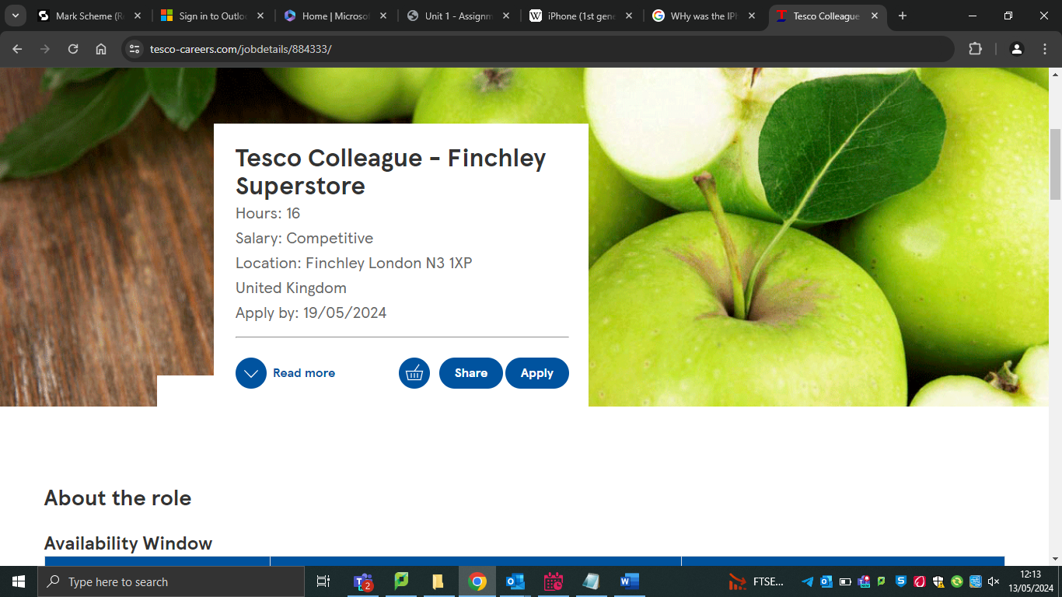

<https://www.tesco-careers.com/jobdetails/884333/>